The Enhancement Document is a very useful document which comprises of the areas in the Application & other related Application where we can enhance the functionality to make it more user friendly & less time consuming
Embellishment Document
for
Pearson Q Global

Author :
Monami Saha, Soumya Sahu , Anupama Sadangi

Table of Contents

1. Enhancement Suggested- 01 3
2. Enhancement Suggested- 02 5
3. Enhancement Suggested- 03 7
4. Enhancement Suggested- 04 9
5. Enhancement Suggested- 05 11
6. Enhancement Suggested- 06 15

1. Enhancement Suggested- 01

Search Facility should be present in the Inventory Page.
- Steps to Navigate to the Inventory Page :

- User is logged in as Pearson Internal user and has access to the back office side of the application.
- Click on the 'Manage Accounts' Link
- Click on any of the Accounts
- Now Click on the Inventory Tab under the Account Details Page
- Select Order Information Radio
- Click on add Button to add any pricing model
- Select any Document Name or any Assessment from the Dropdown
- Select any pricing model either Subscription or Usage
- Provide Proper details
- Click on Save Button
- Now check that Document or Assessment for which the User has added inventory.

- Existing Scenario :
The existing Scenario is that now the user needs to check the whole List to check for the Document or Assessment for which the User has added inventory which is very difficult at the time when there are large number of Assessments or Documents are present in the List as in Figure 1.

Note: The Problem lies here where the user needs to check the whole List to check for the Document or Assessment for which the User has added inventory

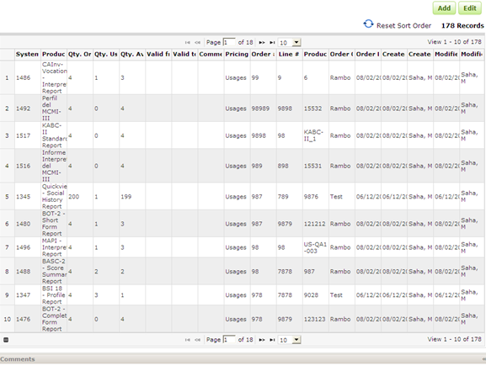
Figure 1: List of Documents or Assessments without the Search Facility

- Enhancement Suggested :
There can be a Search Facility in the Inventory Tab under the Account Details Page which could be used to Search for the specified Document or Assessment for which the User has just added inventory. It could also help the User to Search for any particular Document or Assessment for which he/she has added inventory previously.

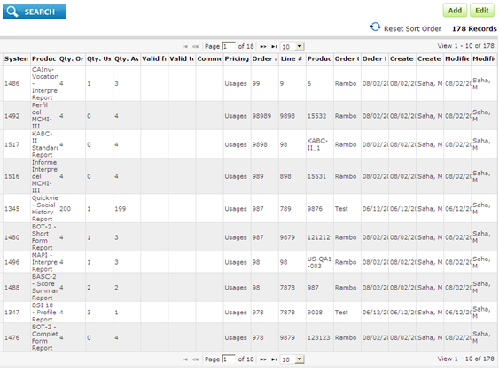
Figure 2: Possibility of the Search Facility

- Benefits of the Enhancement Suggested :

- The Search Facility could be used to Search for the specified Document or Assessment for which the User has just added inventory.
- The Search Facility could also help the User to Search for any particular Document or Assessment for which he/she has added inventory previously.
- The Search Facility could also help the User to save time.

2. Enhancement Suggested- 02

Search Facility should be present in the Manage Global Library Page.
- Steps to Navigate to the Inventory Page :

- User is logged in as Pearson Internal user and has access to the back office side of the application.
- Click on the 'Manage Global Library' Link
- Check for any Assessment suppose : MMPI-2

2. Existing Scenario:
The existing Scenario is that now the user needs to check for a particular Assessment by paginating through the List of Assessments one by one as in Figure 3.

Note: The Problem lies here where the user needs to paginate through the whole List of Assessments one by one for landing up to the Assessment the User wishes to search for. It is time consuming when the list is huge.

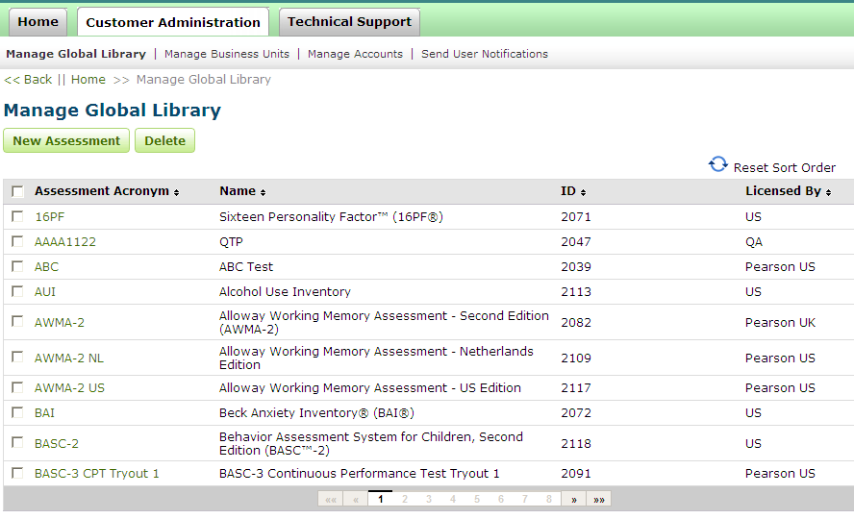
Figure 3: Manage Global Library Page without the Search Facility

- Enhancement Suggested :
There can be a Search Facility in the Manage Global Library Page which could be used to Search for the specified Assessment which the User wishes to search for as in Figure 4.
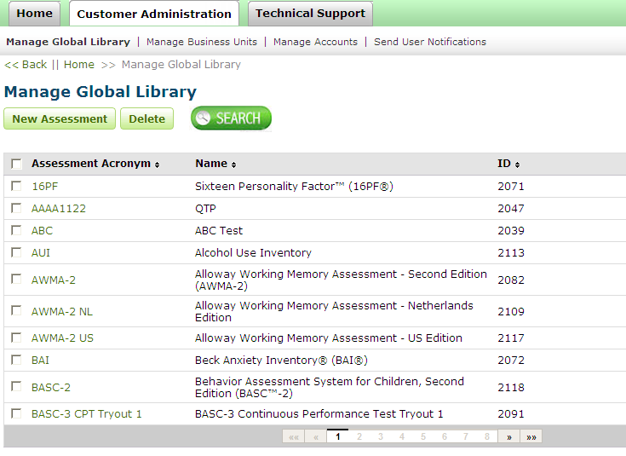
Figure 4: Possibility of the Search Facility in the Manage Global Library Page

- Benefits of the Enhancement Suggested :

- The Search Facility could be used to Search for the specified Assessment which the User wishes to search for.
- The Search Facility could also help the User to save time.

NOTE: This Search facility can be applicable for both Manage Business Unit & Manage Accounts for make it more flexible for the User to search for a particular Business Unit or any particular Account.

3. Enhancement Suggested- 03

Customised Examinee Selection Facility should be present in the Comparator Group Generator Available Examinee Table present in the Comparator Group Generator Page
- Steps to Navigate to the Comparator Group Generator Page :
- User is logged in as Pearson Internal user and has access to the customer office side of the application.
- Select Comparator Group Generator From the Drop Down in More Actions.
- Create a New Group by clicking on the Create Button in the Comparator Group Generator Page.
- Try to add Examinees to the Group from the Available Records List

- Existing Scenario:
The existing Scenario is that now the user has no facility to make a customized selection of the Examinees from the Table to add the Examinees to the Group as in Figure 5.

Note: The Problem lies here where the user needs to select any specific number of Examinees to add to the Group out of large number of Examinees in the Available Examinee List.
Eg: Out of 2000 Examinees the User needs to select 200 Examinees to create a new Group.Everytime the User clicks on any Examinee to be added to the group,the 'Please Wait while your Data is being Loaded' appears & this takes tremendous tiem to add large number of Examinees to the Group

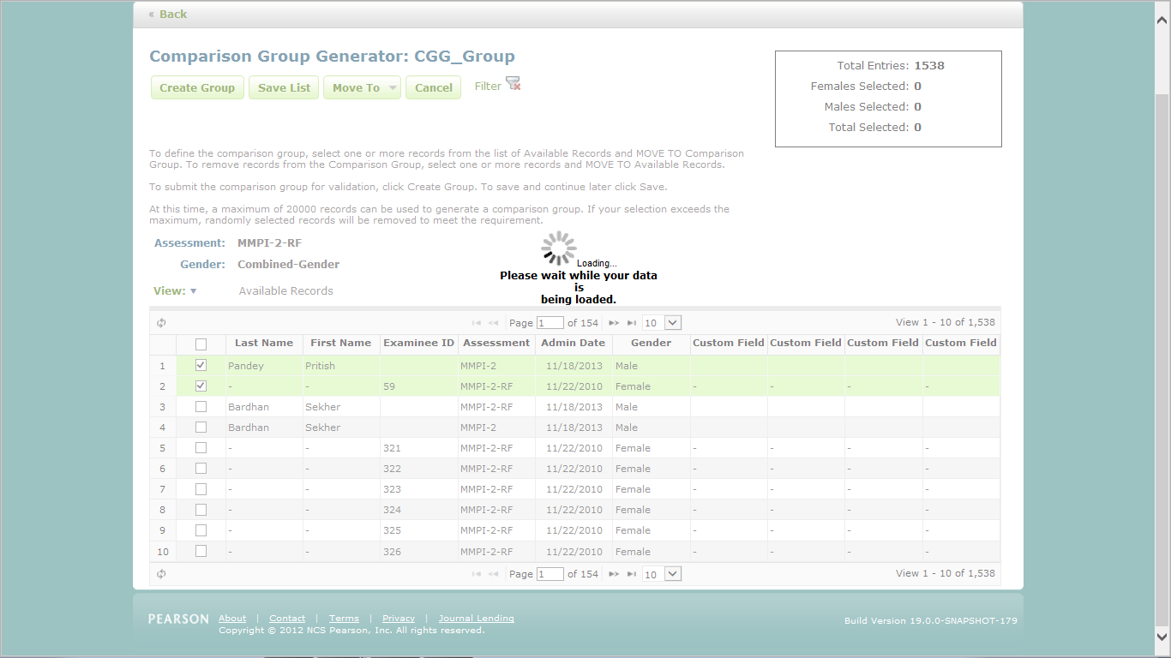

Figure 5: Comparator Group Generator Page: Examinee Selection

- Enhancement Suggested :
There should be a Facility in the Comparator Group Generator Page where the User can select the Examinees Page wise so that it takes less time to Add large number of Examinees to the Group as in Figure 6.
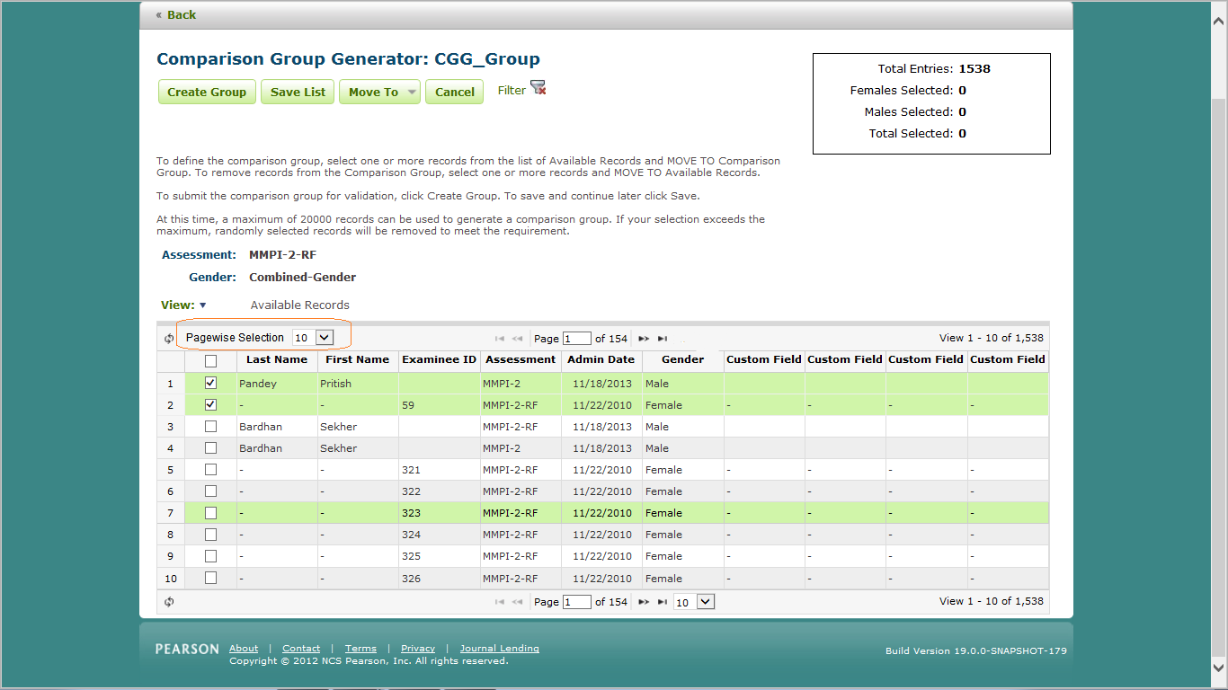
Figure 6: Possibility of the Page wise Selection Facility for the Comparison Group Generator Table in Comparison Group Generator Page.

4. Benefits of the Enhancement Suggested :

- The Page wise Selection Facility would be used to Select customised number of Examinees from the Avaialble List present in the CGG Page & add them in the Group created.
- This will help the User to save much time selecting Examinees one by one from the List.

4. Enhancement Suggested- 04

Aurora & FRPP Reference :Assessment information can be pulled from TestNav, immediately after that test is completed by an examinee.
- Steps to Navigate to the Test Nav Page :
- User is logged in as Pearson Internal user and has access to the Field Research Partner Portal and Aurora Back Office side of the application.
- From the FRPP, send an Invitation Mail to the User's Mail Id
- Open the mial Box to click on the Link
- Test Nav Opens
- Complete the Assessment
- Then Try to land on the Aurora Portal through the Test Nav Exit Page

- Existing Scenario:
The User has to login to the Aurora Portal each time the Test Nav is exited, which requires Refreshing of the List of Examinees a number of times till the Test Nav Details get loaded in Aurora Portal as in Figure 7.

Note: The Problem lies here where the user needs to Refresh the List in the Aurora Portal a number of times to get the List loaded which takes tremendous time to get the List Loaded each time the Assessment Test Nav is Exited .

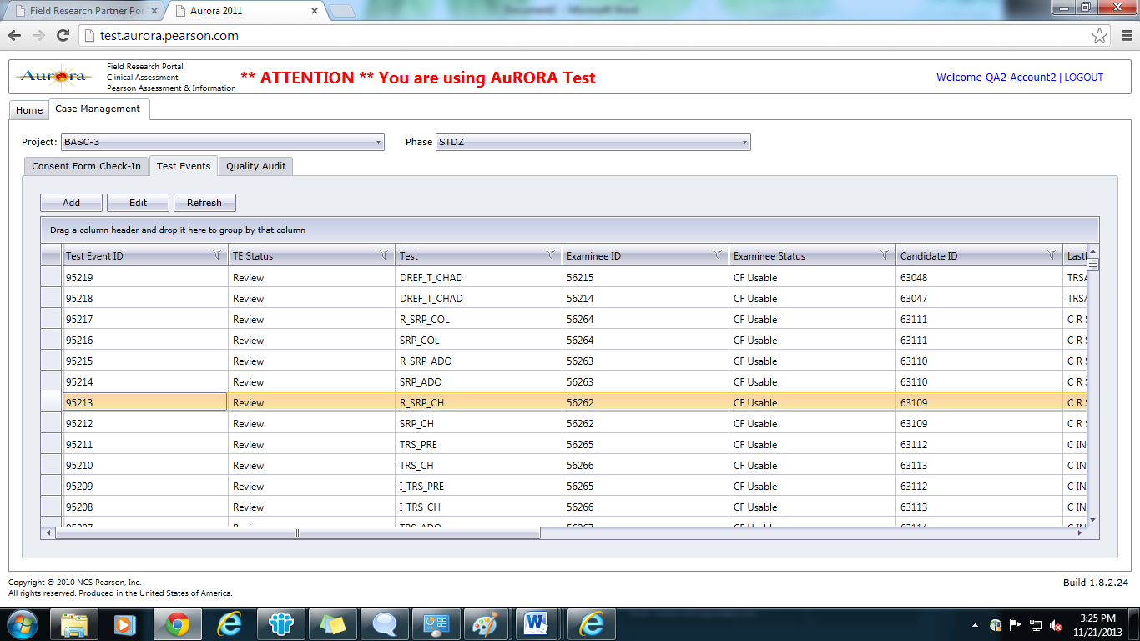

Figure 7: Aurora Portal Refresh Buton

- Enhancement Suggested :
There should be a Facility in the Test Nav Exit Page where the Examinee details will be directly the pulled of the Test data from TestNav to the Aurora Portal & no Refresh is required to Populate the Examinee Details List as in Figure 8.
Figure 8: Directly Data is pulled from Test Nav to Aurora Portal where the Latest Data is appearing at the Top of the List.

4. Benefits of the Enhancement Suggested :

- User will not have login to the Aurora Portal if it gets logged out. Directly the Exit Page will trigger the pulling of Test Nav Data to the Aurora Portal.
- This will help the User to save much time in refreshing the List to populate the List.

5. Enhancement Suggested- 05

Aurora & FRPP Reference:In Aurora Testing when the Test Event ID is generated in Field Research Partner Portal,it should appear as link.

- Steps to Navigate to the 'Field Research Partner Portal' and 'Aurora Back Office' Details Page:
- User is logged in as Pearson Internal user and has access to the Field Research Partner Portal and Aurora Back Office side of the application.

- Existing Scenario:
The existing Scenario is that the user generally hit the above 2 sites for end to end flow.After 1st phase validation in FRPP,a unique Test Event ID is generated.Then the same user has to login to Back Office side and refresh the database until that Test Event ID appears.Then by using that Test Event ID the user does the next phase validation.

Note: The Problem lies here where the user consumes few minutes every time to login to the Aurora Back Office side and refresh the data base.

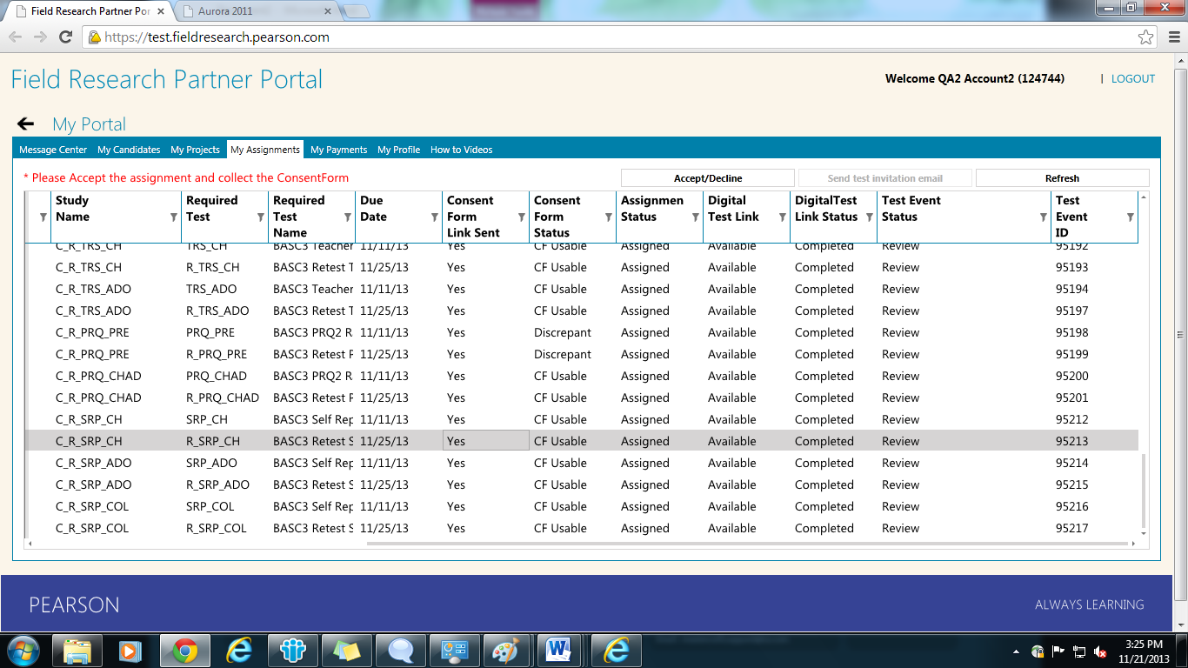

Figure 9: In the highlighted line after the 1st phase validation, the unique Test Event ID i.e. 95213 is generated in FRPP side.

Figure 10:-In Aurora Back Office side by using that Test Event ID(95213) ,the user does the next phase validation.

- Enhancement Suggested :

When the Test Event ID is generated in FRPP,it should appear as link to the user.By clicking upon it,it will automatically redirect to the Back Office part for the 2nd phase validation.As the user has same credential for both the site,then the flow could be easily validated at a single login in FRPP side.
If the user has access to Back Office application,then only it allows the user to do the next phase validation,otherwise it should show some privilege notification.
Figure 11:-The Test Event ID should appear as link.

4. Benefits of the Enhancement Suggested :

- By this process each time the user definitely saves few minutes and the process could be little bit faster than the existing one.
- Also there is no need to login to the Back Office side again & again and no need to refresh the data base every time.

6. Enhancement Suggested- 06

Navigation Facility based on the First Alphabet of the Assessment Name in the Assessment Drop Down in the Home Page.
- Steps to Navigate to the Assessment Drop Down Page :

- User is logged in as Pearson Internal user and has access to the Customer side of the application.
- Select any Examinee from the Examinee List
- Click on the Assign New Assessment Drop Down
- Try to Navigate to any Particular Assessment Name by pressing the First Letter of the Assessment Name Acronym.

- Existing Scenario :
The existing Scenario is that now the User needs to navigate through the whole Assessment List to get to any particular Assessment Name to assign it to the Examinee as in Figure 11.

Note: The Problem lies here where the User needs to check the whole Assessment List in the Drop Down to check for the specific Assessment to assign it to the particular Examinee which takes some time to search out of several Assessments in the List.

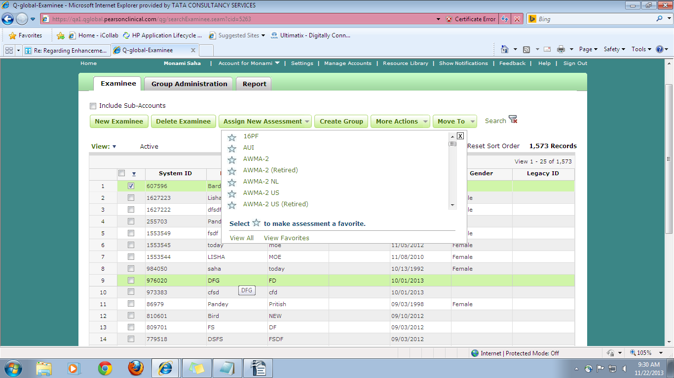
Figure 12: List of Assessments in the Drop Down

- Enhancement Suggested :
There could be a Navigation Facility in the Assessment Drop Down in the Home Page, which could incorporate the Assessment Search by the First Letter of the Assessment Name Acronym in the List.

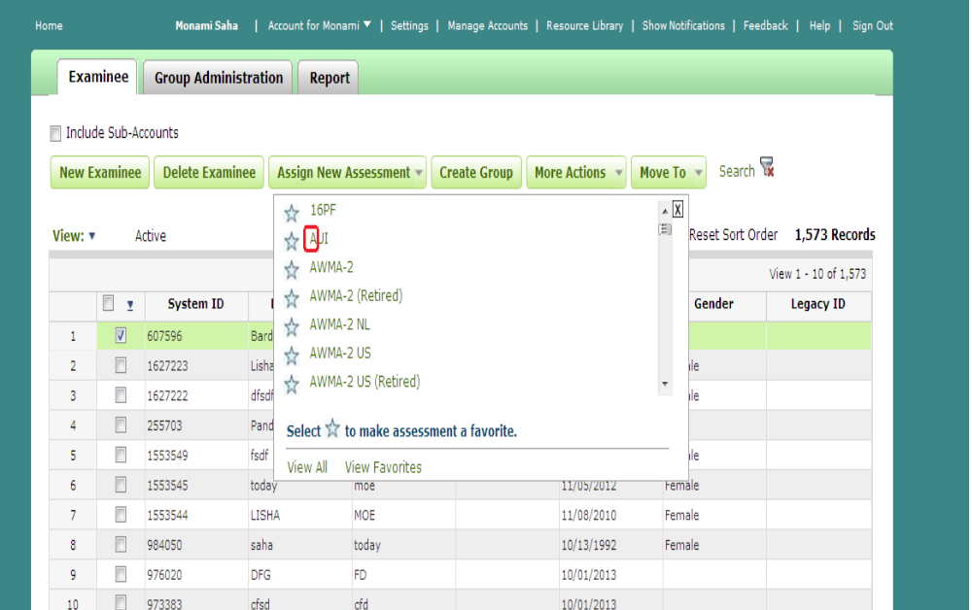
Figure 13: Possibility of the Navigation Facility by First Alphabet of the Assessment Name Acronym

- Benefits of the Enhancement Suggested :

- This Navigation Facility could be used to Search for the specified Assessment by just pressing the First Letter of the Assessment Name.
- The Navigation Facility could also help the User to Search for any particular Assessment swiftly without having to search the whole Drop Down.
- The Navigation Facility could also help the User to save time.

Thank You

